OOAD MINI Project Diagrams

Class Diagram
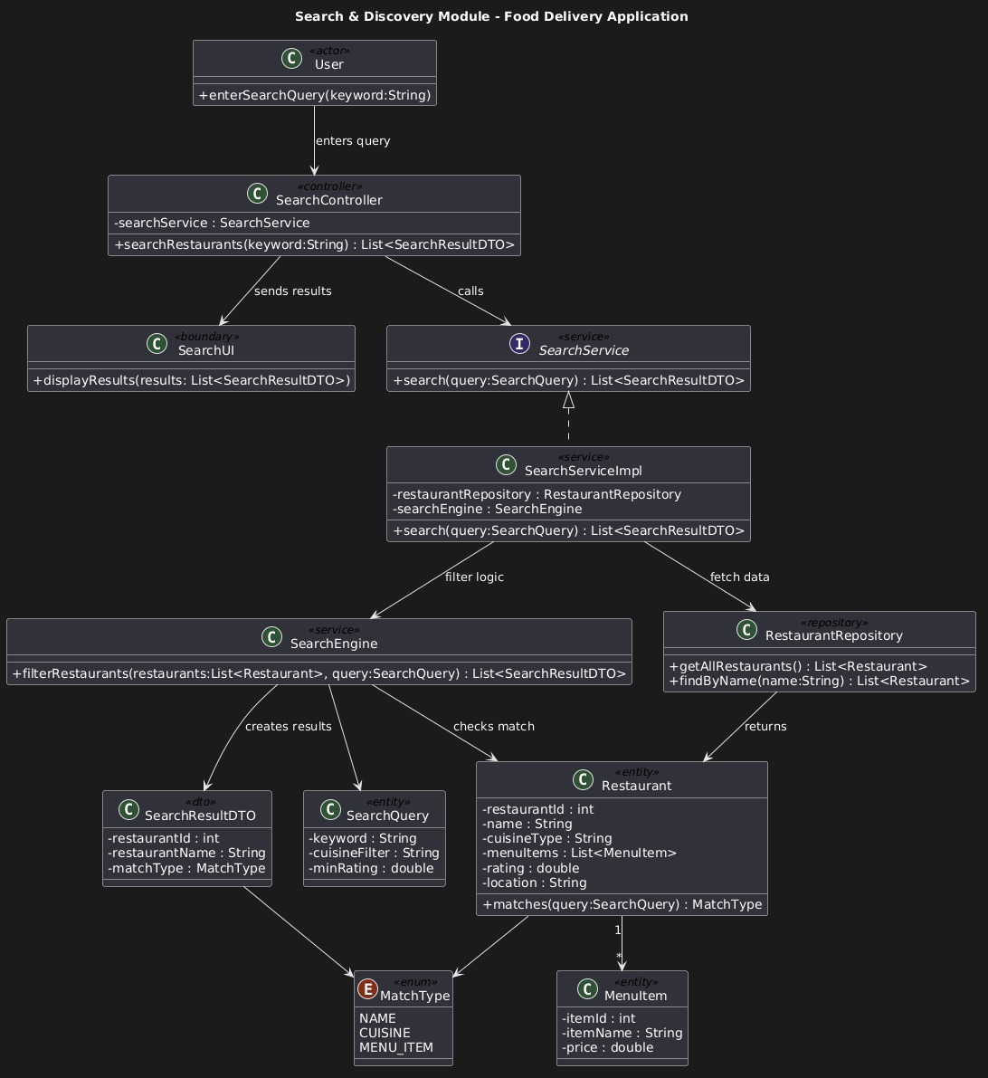

Sequence Diagram
